Microorganism Test Review Name ___________________________

1. What is the common staining technique used to identify bacteria and what colors are positive and negative?
Gram staining Purple(positive) Negative(pink)
2. What is a bacteriophage?Virus that infects bacteria

3. Name all the parts of a virus.protein coat called a capsid, DNA or RNA, tail fibers 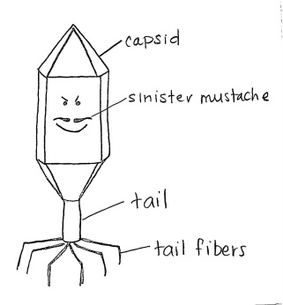

4. What happens in the Lysogenic cycle of a virus? (Include Provirus) see diagram
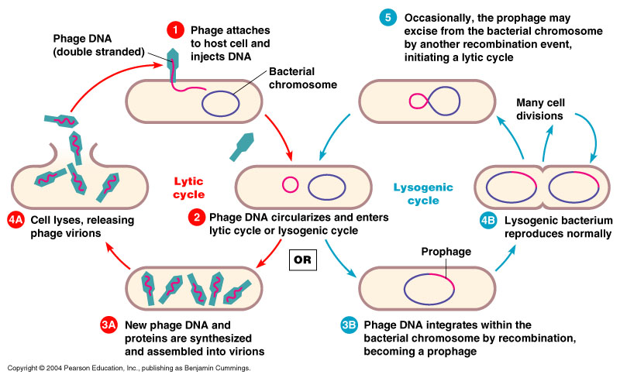
5. What are the events of the Lytic cycle? see diagram

6. Why is a virus not considered alive? They are not cells and can only reproduce, but need a living host cell in order to do so
7. How do bacteria reproduce sexually conjugation and asexually binary fission?

8. What domain contains bacteria? Eubacteria in domain Bacteria Archaebacteria in domain Archaea

9. What treatment can be used to treat a bacterial infection? antibiotics

10. What treatment can be used to prevent a viral infection? Vaccines

11. A retrovirus contains which nucleic acid? __RNA_______ Name a retrovirus and tell why they are so dangerous? HIV—carry out reverse transcription—host cell’s DNA is made from viral nucleic acid—no Bueno
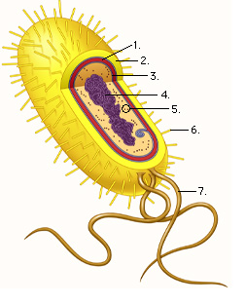
12. Label the following prokaryote cell:
1. cell wall
2. capsule
3. cell membrane
4. DNA
5. ribosome
6. pili
7. flagella

13. List the shapes and groupings common to Eubacteria:
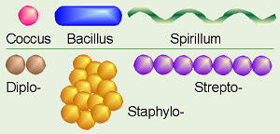

14. How can you prevent food from spoiling? Refrigeration and freezing(salt and vinegar back in the day)

15. What is the symbiotic relationship plant roots have with fungi? Mycorrhizae

16. Define each of the following: hyphae, mycelium, fruiting body and spores
In notes, on study guides, in the glossary, and of course your local internet

17. Draw and label the following protists: Amoeba (how does an Amoeba move pseudopodia?) , Paramecium (what is the function of a contractile vacuolepumps out excess water?)and Euglena (what is special about the Euglena?photosynthetic and capable of movement) Refer to the “coloring” worksheets for diagrams, or your book, OR…..your local internet!!

18. What is another name for animal like protists? protozoa

19. What characteristics classify an organism as a fungus? Most multicellular, heterotrophic decomposers and chitin in cell walls

20. What value does frequent hand washing serve? prevents the spread of diseases caused by microorganisms

21. What is the difference between photoautotrophs--photosynthetic and chemoautotrophs obtain energy directly from inorganic molecules?

22. Is HIV due to lytic or lysogenic infection? lysogenic

23. Viruses that contain RNA are known as_____retroviruses_________.
24. How do antibiotics kill bacteria? Break down the cell wall of prevent cell wall formation of Gram positive bacteria

25. Archaebacteria are found in very _____extreme____environments. Deep sea vents, geysers, volcanoes, Dead Sea, Great Salt Lake, grazing animal digestive tracts

26. What characteristic is common to ALL protists? eukaryotic

27. What characteristic is common to ALL fungi? Eukaryotic heterotrophs and decomposers

28. To what domain do protists belong? Eukarya

